# [**8 Characters Who Need a Little Romance in the 2020-2021 Season**](https://www.tvinsider.com/gallery/tv-characters-romance-2020-2021/)

[***Meredith Jacobs***](https://www.tvinsider.com/author/meredith-jacobs/)AUGUST 19, 6:00 PM

[COMMENTS](https://www.tvinsider.com/gallery/tv-characters-romance-2020-2021/#spotim)

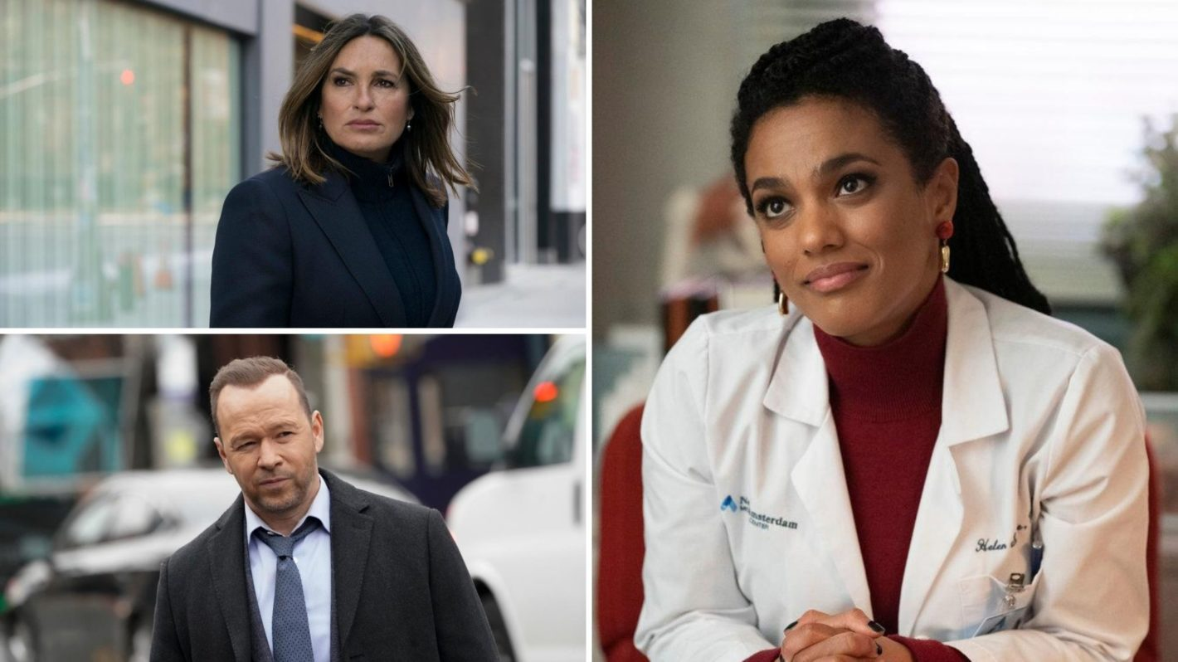

Virginia Sherwood/NBC; John Paul Filo/CBS; Virginia Sherwood/NBC

Relationships can be tough, especially on a TV show, where drama and romance usually go hand in hand.

But people can always use a little love in their lives, especially if they're succeeding at work, as these characters are. Whether they spend their days saving lives in a hospital or in the field or tracking down bad guys with a badge, they could use a little "me time," and what better way to get that than to have someone to come home to?

[SEE ALSO](https://www.tvinsider.com/gallery/tv-couples-2020-2021-one-chicago-ncis-greys-anatomy-new-amsterdam/)

### [**8 New Couples We Could See in the Next TV Season**](https://www.tvinsider.com/gallery/tv-couples-2020-2021-one-chicago-ncis-greys-anatomy-new-amsterdam/)

From romance in bullpens and hospital hallways to Chicago love, these pairs seem likely.

From characters who have tried time and time again to make a relationship work (like [***NCIS*'**](https://www.tvinsider.com/show/ncis/) Leroy Jethro Gibbs) or just went through a breakup (like [***Brooklyn Nine-Nine*'s**](https://www.tvinsider.com/show/brooklyn-nine-nine/) Rosa Diaz), we take a look at the characters who could use a little romance in their lives in the 2020-2021 season below.



Jack Zeman / FOX

### ***9-1-1*'s Evan "Buck" Buckley (Oliver Stark)**

The firefighter *finally* got [**closure in his relationship**](https://www.tvinsider.com/934026/911-season-3-finale-abby-returns-buck-closure-maddie-pregnant/) with former 9-1-1 dispatcher Abby Clark ([**Connie Britton**](https://www.tvinsider.com/people/connie-britton/)) — she’s now engaged — and he hasn’t had a serious relationship since she left at the end of Season 1. Let’s see how seeing Abby again affects his personal life going forward and if he’s ready to settle down. After all, his sister Maddie ([**Jennifer Love Hewitt**](https://www.tvinsider.com/people/jennifer-love-hewitt/)) is pregnant; that may get him thinking about his future.

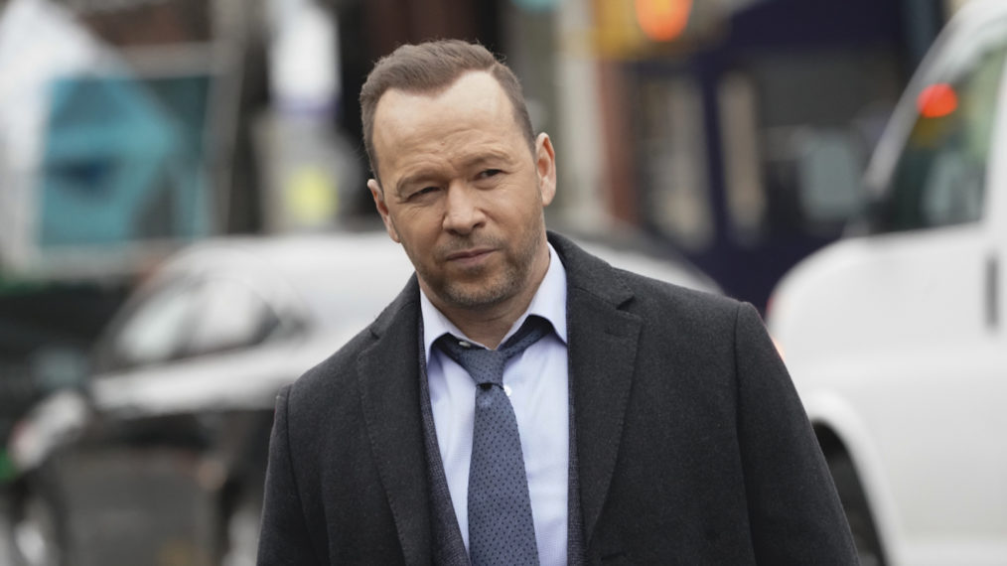

John Paul Filo/CBS

### ***Blue Bloods*' Danny Reagan (Donnie Wahlberg)**

No one will ever mean what his late wife, Linda ([**Amy Carlson**](https://www.tvinsider.com/people/amy-carlson/)), did to him, obviously, and while viewers may not be ready to see him with someone new, the series has teased the possibility, especially with medium Maggie (Callie Thorne). And, of course, there are always those who hope that he and Detective Maria Baez ([**Marisa Ramirez**](https://www.tvinsider.com/people/marisa-ramirez/)) follow in the footsteps of so many other partners on procedurals and get together. Let’s at least see Danny take a step towards perhaps getting back out there in Season 11.



John P. Fleenor/NBC

### ***Brooklyn Nine-Nine*'s Detective Rosa Diaz (Stephanie Beatriz)**

Everyone knows not to mess with this detective, but we have seen her softer side come out at times, including when she’s in a relationship (most recently with Jocelyn). In Season 7, Rosa revealed to Captain Holt ([**Andre Braugher**](https://www.tvinsider.com/people/andre-braugher/)) that her girlfriend broke up with her, but we didn’t see quite enough of them together. Whether Rosa finds someone else on the force (but maybe not as crazy as [**Jason Mantzoukas’**](https://www.tvinsider.com/people/jason-mantzoukas/) Adrian Pimento) or not, let’s have her share that person a bit more with the rest of the squad. After all, we do so love it when Rosa opens up about herself.



Adrian Burrows/NBC

### ***Chicago Fire*'s Sylvie Brett (Kara Killmer)**

To be fair, we’re just hoping that there’s some happiness of any kind coming for the paramedic in Season 9. On a TV show, that’s likely to come via a romantic relationship. After all, she’s had a rough time lately, from meeting her birth mom only to lose her when she died in childbirth to her partner in Ambulance 61 leaving ([**Annie Ilonzeh**](https://www.tvinsider.com/people/annie-ilonzeh/) is [**exiting ahead of the new season**](https://www.tvinsider.com/931171/chicago-fire-annie-ilonzeh-leaving-emily-foster-season-9/)). Maybe she and firefighter Matt Casey ([**Jesse Spencer**](https://www.tvinsider.com/people/jesse-spencer/)) finally do something about their slow burn romance or she finds someone new.

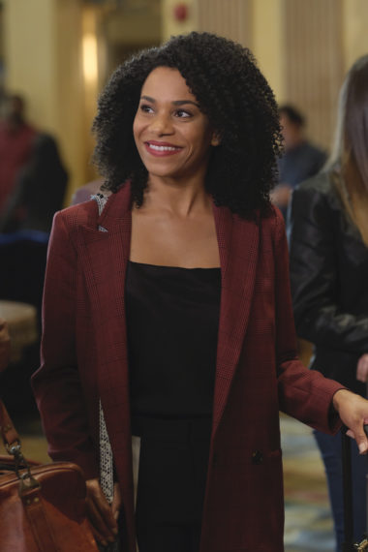

ABC/Tony Rivetti

### ***Grey's Anatomy*'s Dr. Maggie Pierce (Kelly McCreary)**

Maggie’s relationship with fellow doc Jackson Avery ([**Jesse Williams**](https://www.tvinsider.com/people/jesse-williams/)) was messy (at the end and after), but it looked like she’d finally found someone new when she reconnected with Dr. Winston Ndugu (Anthony Hill) at a medical conference in Season 16. With [**Hill now a series regular**](https://www.tvinsider.com/943602/greys-anatomy-season-17-station-19-season-4-cast-changes/), chances are that relationship will continue. Let’s just hope it’s not as drama-filled as others on the show.

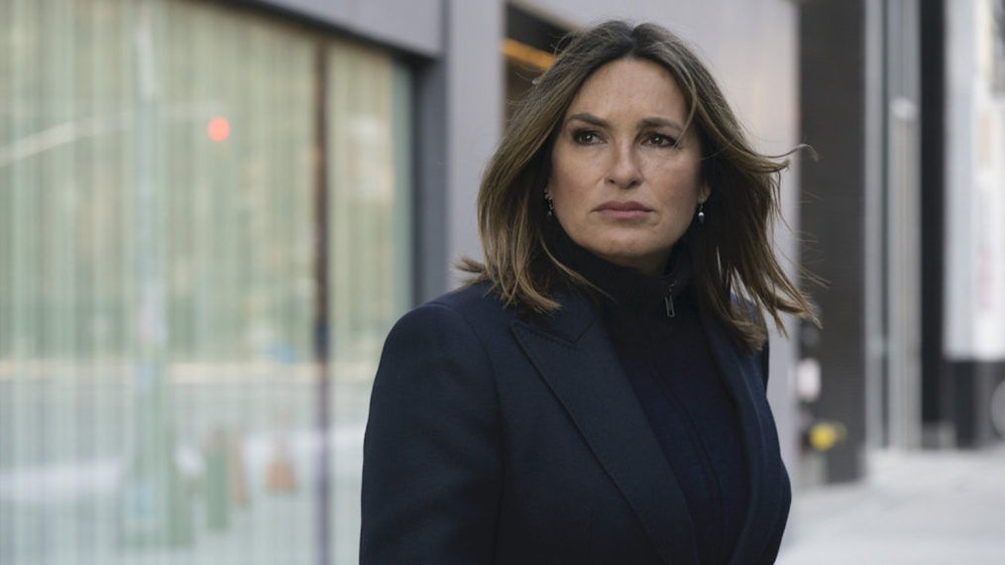

Virginia Sherwood/NBC

### ***Law & Order: SVU*'s Captain Olivia Benson (Mariska Hargitay)**

No, we’re not hoping for a crossover romance with her former partner, Elliot Stabler ([**Christopher Meloni**](https://www.tvinsider.com/people/christopher-meloni/)) now [**heading up his own unit**](https://www.tvinsider.com/941933/law-order-svu-benson-stabler-reunion-christopher-meloni/) on [***Law & Order: Organized Crime***](https://www.tvinsider.com/show/law-order-organized-crime/). (It sounds like he’ll be dealing with enough that a relationship is going to be the last thing on his mind.) But we’ve seen Olivia succeed at work and as a mother in recent years, so we’re hoping that we see more of her social side. [**Rick Fox’s Edgar Goodwin**](https://www.tvinsider.com/932989/law-order-svu-season-22-stabler-returning-christopher-meloni/) was supposed to return “in a more social way” if Season 21 hadn’t ended early, showrunner Warren Leight revealed on the show’s podcast. Whether he comes back in Season 22, [**Raul Esparza**](https://www.tvinsider.com/people/raul-esparza/)‘s Barba returns for that [**dinner he and Olivia had planned**](https://www.tvinsider.com/912367/law-order-svu-season-21-episode-13-olivia-barba-returns/), or she meets someone new, let’s see something.

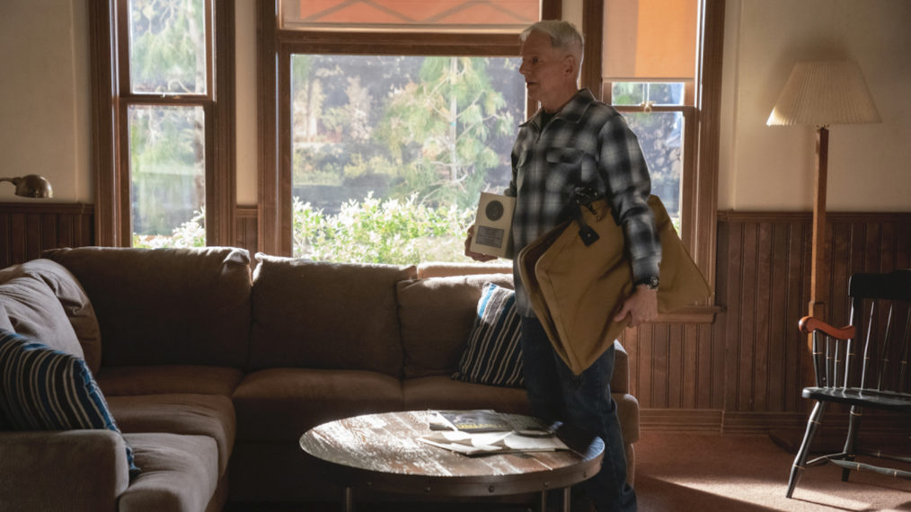

Sonja Flemming/CBS

### ***NCIS*' Special Agent Leroy Jethro Gibbs (Mark Harmon)**

As we’ve seen (again and again), no one can replace his first wife, Shannon, whom he lost along with their daughter, but Gibbs has married several times since and tried to make relationships work. While there has been something between him and forensic psychologist Jacqueline “Jack” Sloane, [**Maria Bello**](https://www.tvinsider.com/people/maria-bello/) is [**exiting after eight episodes**](https://www.tvinsider.com/gallery/ncis-maria-bello-leaving-jack-exit-storylines/) in Season 18. Whether it’s the acknowledgement of what could exist between those two, a new recurring character, or an off-screen love interest, let’s see that side of him explored again.

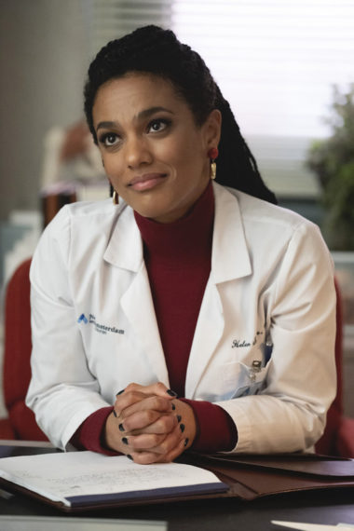

Virginia Sherwood/NBC

### ***New Amsterdam*'s Dr. Helen Sharpe (Freema Agyeman)**

It was unclear if Helen’s night out with the hospital’s newest doctor, Cassian Shin ([**Daniel Dae Kim**](https://www.tvinsider.com/people/daniel-dae-kim/)), was the start of something new, so let’s assume she’s still single. Season 3 could see that develop into something more or finally do something about the chemistry between Agyeman and [**Ryan Eggold**](https://www.tvinsider.com/people/ryan-eggold/) (who plays Dr. Max Goodwin). Either way, we’re just hoping that Helen gets what she wants from her personal life (and perhaps return to her desire to have kids, with or without a man in her life).